Contents

Concept and Functionality 3

Meta concept, tone and theming 3

Conversation and Dialog 3

Interactive Play (and the Stein-O-Matic 3000 Mobile App) 4

Activity Scheduling (The Daily Kickstart) 4

Leveling System (Earning IQ points and Achievements) 5

User Profile 5

Games 6

Einstein’s Research (Narrated Videos) 6

The Einstein Robot 7

OFFLINE Mode 7

Keyword (voice) Navigation 7

Offline Activities 8

CLOUD CONNECTED Mode 8

Navigation - Cloud Word 9

Connected Activities 9

APP CONNECTED Mode 9

The Stein-O-matic 3000 (Mobile App) 10

Genius ID – Learning about you 11

My Profile 12

My Headshot 13

My Progress 14

Brain Games – Challenging your mind 16

Brain Game Option #1: Hidden Object 16

Brain Game Option #2: Mag-Neato 17

Brain Game Option #3: Massamatics 18

Brain Game Option #4: Threes 19

Brain Game Option #5: Did you NO? 20

Pi Chart – Scheduling Daily Activities 21

Digital Lab Experiments – Combining Imagination and Science 23

Gravity 23

Research Files – Learning from the Master 24

DIALOG/FLOW 1 – Connecting Einstein 26



# Concept and Functionality

***The intellect of the 20th century’s most well known scientific genius has been downloaded into a twelve- inch tall robotic body and is looking for a worthy assistant and companion to pass on his knowledge and insight. Lucky you!***

Einstein is an interactive, connected toy containing light robotics and featuring experiences that focus on imagination, personalization and entertaining science-based topics. As the user’s constant companion, Einstein will teach, play and amuse via an expandable library of activities and interactions.

The Einstein doll employs miniturized robotics to display facial expressions during speech and limited, bi-pedal mobility; while a text to speech system allows extensive and expansive dialog including multi-path conversation.

## Meta concept, tone and theming

The meta-concept behind the Einstein robot is that the genius of Einstein has been downloaded into a robotic companion, and that you (the user) will become his protégé as he trains you to become the 21st century’s foremost genius. Hey, everyone needs a goal!

Like the man himself, activities with Einstein are often knowledge-based, but always driven by humor and imagination. For the purpose of playfulness and fun, Einstein will appear to have an understanding that his intellect has been placed into a small robot. This will allow us to generate humorous scenarios and dialog.

## Conversation and Dialog

Einstein will do a lot of talking in his recognizable, german accent.

A great reference for Einstein’s voice can be found here: <https://www.youtube.com/watch?v=OamFZCFfQkg>

The general tone of Einstein’s conversation with the user will be light-hearted and playful, as in this sample dialog:

EINSTEIN  
Ooh-hoo-hoo, hello there! So nice to see a friendly face after being in a state of psycho-kinectistasis for so long! Ahhh, it’s wonderful to finally wake up and smell the atoms! (chuckles) So, let’s get things started, shall we?

Einstein will contain a significant amount of branching dialog in order to converse with the user.

Additional dialog will be serviced via the cloud as needed.

*See the separate ‘Dialog Design.docx’ document for information on how dialog is constructed, its design syntax and its features. A single dialog example*

## Interactive Play (and the Stein-O-Matic 3000 Mobile App)

Play with Einstein is driven by the internet connected Einstein ‘doll’ in concert with the accompanying mobile App (the Stein-O-matic 3000 science tool!) with which both the user and the doll seamlessly and continuously interact. Einstein will react constantly through vocal responses with the user, as he/she engages each activity on the Stein-O-matic, offering helpful hints and encouragement during play.

*Most games and activities use the doll in concert with the mobile App to create a unique ‘companion’ centered experience; however, when the doll is offline, there is a limited library of on-board content that can be enjoyed. In addition, several of the games can be on the Stein-O-Matic 3000 mobile app without the doll being connected to it.*

## Activity Scheduling (The Daily Kickstart)

As the child’s ‘constant companion,’ Einstein will not wait for the user to engage him. At the beginning of each day, if ‘awake,’ Einstein will automatically do a number of things to seed the day with activities. In addition, if ‘enabled,’ the Stein-O-Matic will automatically engage the user in a light, but meaningful way.

Einstein’s Daily Kickstart routine will consist of any number of the following conversation/activity seeds:

* A new day welcome. In some cases, this will include an Einstein **quote**. If the user has entered how he/she is feeling today via the Stein-O-Matic, he will comment on it.
* A daily Kickstart your brain experience in which Einstein challenges his protégé with a **science fact**, several **Brain Game assignments**, a **joke** and sometimes a daily **goal**.
* A reminder to either look at the user’s schedule or a reminder of upcoming events (based on Pi Chart)
* A reminder that Einstein can always talk to you about ‘other’ things.

The Stein-O-Matic Daily Kickstart includes:

* A **wakeup call** from Einstein (if set in Pi-chart)
* A couple brief questions to help Einstein react to the user better throughout the day. These include questions about Mood, energy, goals etc.

|  |
| --- |
| Daily Kickstart Info Boxes  The concept of the Daily Kickstart is an important (and unique) feature designed to allow Einstein to engage a user, rather than the user having to figure out how to engage Einstein first. Throughout this doc, sections in green provide additional information, functionality and features about Einstein’s Daily Kickstart. |

## Leveling System (Earning IQ points and Achievements)

On his path to genius, the user will have the opportunity to climb the IQ ladder by completing games, engaging in activities and simply interacting with Einstein. The user’s current IQ level and corresponding title (protégé, astronomical apprentice or even boy/girl genius) will be visible in the Genius ID section of the Stein-O-Matic. *Einstein will always use the user’s current Title appropriately during spoken conversations.*

In addition to a new title, the user will unlock additional avatar items for his profile picture (an impressive ID photo is essential in the world of academia!) and other content.

Advancing in the leveling system will:

* Unlock rewards
* Unlock content
* Unlock new avatar pieces
* Unlock Special Einstein interactions and responses
* Change the user’s current Title (which starts as ‘Assistant’)

To increase his/her level the user earns IQ points by:

1. Excelling at Brain Games challenges (see Brain Games – Challenging your mind)
2. Providing certain optional Profile information (see My Profile)
3. Earning Achievement Badges
4. Interacting daily with Einstein

The player can always check his/her progress in the Stein-O-Matic 3000 by selecting their Genius ID badge and viewing My Progress.

*See the Stein-O-Matic > Genius ID section for more information.*

## User Profile

Einstein will learn more about the user over time. This information will be used to personalize Einstein’s interactions.

Personal information about the user is collected in a User Profile database and is accessed and used as indicated in the various sections of this document. **Whenever possible, games and activities integrate the user’s profile information in order to personalize the experience.**

Information is added directly to the User Profile via the Stein-O-Matic 3000 App or collected through verbal interactions with Einstein – such as when he asks the user their favorite color*.*

*See the Stein-O-Matic > Genius ID > User Profile section for more details*

## Games

The user can play games and activities with Einstein, the extent of which is limited by the doll’s current connectivity mode. Games vary widely in depth of play. Additionally, most games REQUIRE the doll to be in a fully connected mode and the user to have access to the mobile App.

All games and activities can be categorized into the following categories:

* **Brain Game Challenges** are micro games assigned by Einstein at various times, and accessed by the user via the Stein-O-matic. Completing challenges awards the user with IQ points. Once issued, some Brain Games can be played without Einstein being connected; however, the experience is enhanced with his verbal help and responses if he remains connected. *Note: some challenges REQUIRE Einstein to be connected.*

*Brain Games are designed to be data driven so that new ‘levels’ can be easily created and downloaded after release.*

* **Experiments** are more in-depth, multi-level Apps that are accessible via the Stein-O-Matic 3000. Each Experiment deals with a single scientific principle or area of study (like gravity, chemistry or magnetism,) wrapped in a fun, imaginary premise. Playing these games are meant to be both challenging and informative.
* When Einstein is offline, he will have some on-board activities. All of these **‘takeaway activities’** are verbal games, like a story generator or riddles.

Games can be accessed through verbal command with the Einstein doll, by navigating to the game via keywords; or launched directly from the mobile App. A few games do not require the Stein-O-matic 3000 App to play, but most use the App in conjunction with the doll for a highly interactive experience.

## Einstein’s Research (Narrated Videos)

Under the title of ‘research’ the user can ask Einstein to explain some of his most popular theories and subjects, like:

* The general and special Theories of Relativity
* Time
* Gravity
* Photoelectric effect

For each of these topics, a short motion graphic presentation will play out on the Stein-O-Matic as Einstein provides the narration.

*In addition to videos on Einstein’s popular areas of research, other knowledge topics will become available post launch. These will be offered as in-App purchses.*

# The Einstein Robot

Einstein can be in different MODES based on his connectivity status. Einstein’s current MODE determines what content is accessible to the user and the extent of interaction possible with Einstein at that moment.

1. FULLY CONNECTED – Einstein is Fully Connected when he is connected to both the internet (cloud service) and the mobile app. In this MODE, Einstein has access to all features.
2. CLOUD CONNECTED – When Einstein is connected to the internet, but not the mobile App, he has access to expanded cloud content downloads, but no direct App interaction is possible. *During this stage, when the mobile app is loaded, it will constantly remind the user to connect Einstein; and Einstein will frequently do the same.*
3. APP CONNNECTED – It’s possible that Einstein is not setup to access the internet, setup fails or Einstein temporarily looses the connection. In this case, Einstein will be able to interact with the mobile App features, but will not have access to cloud features.
4. OFFLINE – When Einstein is not connected to the internet or the mobile App, he only has access to his onboard (keyword-based) communication tree and downloaded/take-away features. In this state, both Einstein and the mobile App will frequently insist on ‘getting connected.’

## OFFLINE Mode

The robot is in offline mode when it has no connection to the internet or to the mobile App.

WHEN OFFLINE, Einstein has reduced functionality and can only access a Limited User Profile and offline activities.

### Keyword (voice) Navigation

In offline mode, Einstein only reacts to a core set of keywords that allow the user to navigate the offline content menu.

Below is a first pass flow example of how the user may navigate Einstein’s on-board content tree using only keywords. *Note: the nodes in pink require Einstein to be connected. Nodes in blue assume that Einstein is able to have a limited amount of on-board ‘knowledge’ about himself. This is needed for an ‘out of the box’ experiment where the user wants to ask Einstein a question about his own work, life, etc.*

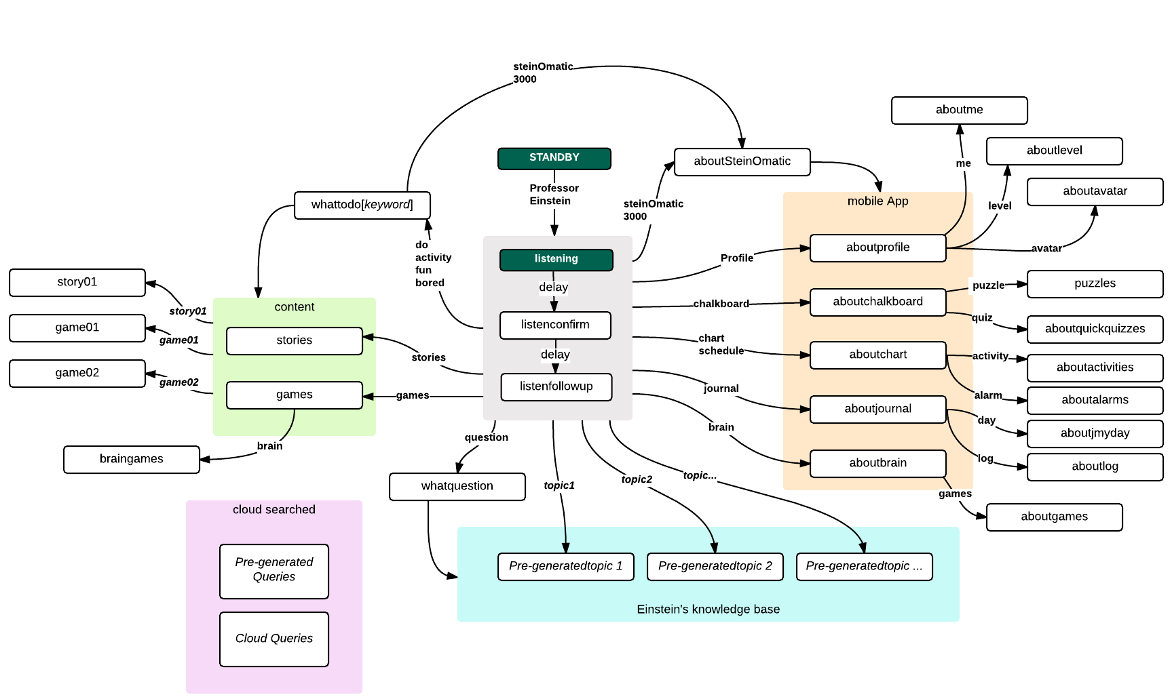

### Offline Activities

In offline mode, Einstein has access to a limited set of onboard/takeaway content.

Imagine This!

Imagine This! is a MadLibs style story (playable in offline mode) wherein Einstein asks the user to provide options to seed some fantastic, and possibly made up, stories of the professor’s misadventures. In addition to initial choices, information from the user’s profile is added to fill in additional details. Finally, as Einstein tells the story, the user is offered points at which the user can make decisions that change the course of the story.

*An enhanced version of Imagine This! is available if Einstein is connected to the Stein-O-matic App.*

## CLOUD CONNECTED Mode

Einstein can connect to a local Wi-Fi router.

When connected, Einstein can access the cloud service.

Connection to the cloud service will provide the following expanded features:

* Einstein can download new activity scripts
* Einstein can download new keyword groups and dialog scripts
* Einstein has access to special information such as weather, location based information,etc *…*

When connected, Einstein will provide answers to natural spoken queries IF the user asks a question and Einstein does not detect an existing keyword (eg. Siri/google Voice query).

### Navigation - Cloud Word

In cloud connected mode, Einstein will react to a far wider range of verbal commands and queries.

Cloud queries

If Einstein does not recognize a keyword, the sentence will be sent to the cloud service to be processed as a Watson/Siri/Cortana/Google voice style query.

### Connected Activities

When Einstein is connected to the internet only, he has access to his cloud connected subset of activities.

## APP CONNECTED Mode

Einstein can connect directly to the Stein-O-matic mobile App.

When connected, Einstein can trigger UI actions and, conversely, can respond verbally to user actions taken when engaging the UI.

*Note: Quick reactions from Einstein, based on action taken by the user within the mobile App, is essential to this Einstein experience.*.

# The Stein-O-matic 3000 (Mobile App)

Early on in the setup process, Einstein introduces the user to a key piece of scientific equipment that he refers to as the Stein-O-matic 3000.

The ‘3000’ or ‘Stein-O-Matic’ is an app with a retro 50’s aesthetic and will, in Einstein’s words “help us organize our searches, our games, our work, and our experiments!”

The App drives all sorts of quick interactive moments between the user and the doll, provides daily activities and tests setup by Einstein himself to challenge and expand the user’s mind, offers a couple in-depth video game-like experiences (that can be expanded in future downloads), provides the user a visual window into his/her profile and progress as a genius-in-training, allows the user to schedule Einstein’s activities each day… and more.

Connection Reminders

A priority of the App is to ensure Einstein is connected as much as possible. When it detects that Einstein is offline it will (frequently) remind the user to connect him. When the Stein-O-Matic is launched, if Einstein is not connected, the user will be instructed to do so. The user has to actively cancel or connect Einstein to remove the popup.

Additionally, ghosted/inactive icons serve as a reminder to the user that additional functionality is available ONLY if Einstein is connected.

Entry Screen

When the Stein-O-Matic is launched, the user must first create a profile and then login with a simulated ‘thumbprint scan.’ When a new profile is created, the user enters a name, places his/her thumb in the scan area and the thumbprint is ‘scanned.’ Einstein immediately comments on the fact that the user has the “arches, loops and whorls of a genius!”

*After the profile is created, the user will only need to touch his/her thumbprint to load his/her profile and access the Stein-O-Matic content each time.*

The Stein-O-Matic entry screen allows up to three users to create and manage their profiles. When a different user wants to login, he/she simple touches their thumbprint for a simulated scan. Doing so will open the Stein-O-Matic with the user’s individual profile information and alert Einstein to the user with which he will be interacting.

Interaction with the doll

The Stein-O-matic 3000 companion App enhances the interaction with the Einstein doll in several ways.

The App is directly connected to the doll’s internal router and ‘knows’ when Einstein is online. Furthermore, it can communicate directly with the doll (and vice versa) allowing Einstein to:

* React quickly to actions taken within the App.
* Place visual cues on the App’s screen (in addition to verbal help) to coincide with the user’s actions within a game, or as a means of prompting the user what to do next.

Whenever the user is presented with an animated word balloon, it indicates that Einstein has something specific to say. Touching a word balloon in the Stein-O-Matic will prompt Einstein to respond.

Using the App

Once the App is installed and Einstein is connected to it, he will react verbally to the user’s actions within the App. Einstein is their constant companion!

The App consists of the following core content areas:

* Genius ID
* Brain Games
* Pi Chart (activity scheduler)
* Experiments
* Research Files

## Genius ID – Learning about you

The Genius ID badge shows predominantly when the Stein-O-matic is accessed.

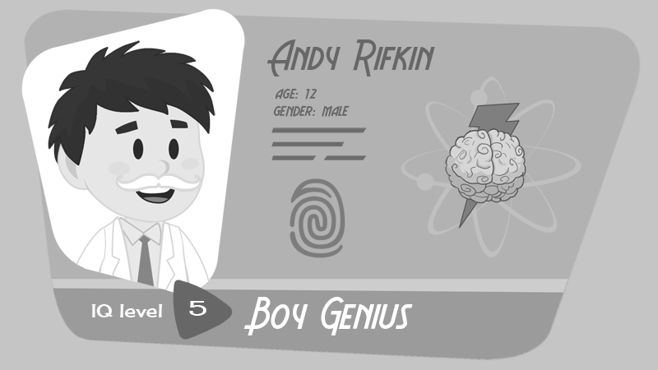

It consists of the following elements:

* The user’s customized Headshot
* Full Name and info (age/gender)
* IQ Level indicator
* Current title
* The Achievement Badge that the user has elected to display on the ID

Touching any portion of the Genius ID will allow the user to view the appropriate information

For example, touching the Headshot image will lead the player to the headshot customizer, touching the name/info section will bring up the user’s profile entry information, touching the Achievement Badge will let the user view all earned badges, etc.

### My Profile

User Profile information can be entered directly into the user’s profile. To access the profile section, the user taps his/her Name on the Genius ID.

The My Profile screens allow the user to easily enter personal information using text fields, dropdown menus or, in some case, icon selections. When connected, Einstein has access to ALL information stored in the User Profile.

Note that profile information will be collected when using other sections of the App as well, or when in conversation with Einstein. For example, when playing a certain game, Einstein may ask the user for information. If this information is relevant to his/her profile, it will be stored appropriately in the User Profile.

|  |
| --- |
| Daily Kickstart  During the Daily Kickstart, the Stein-O-Matic may ask the user to enter some timely, personal information, like the user’s mood or a daily goal, that it stores in the user’s temporary profile. This information will be accessed by Einstein during the day’s conversations, especially during his Kickstart routine. |

IQ Rewards

The user will be awarded IQ points as an incentive for entering certain levels of information.

|  |  |
| --- | --- |
| **Profile Information** | |
| Light Level information | |
|  | Name |
|  | Age |
|  | Eye color |
|  | Hair color |
|  | Height |
|  | Weight |
| Medium Level information | |
|  | Best friend(s) |
|  | Favorite talent |
|  | Favorite color |
|  | Favorite animal |
|  | Favorite food |
|  | Favorite drink |
|  | Favorite flavor |
|  | Favorite Hobby |
|  | Favorite Sport |
|  | Last Book read |
|  | Favorite book |
|  | Favorite writer |
|  | Favorite movie |
|  | Favorite actor/actress |
|  | Favorite singer |
|  | Favorite song |
| Deep Level information | |
|  | Best super power |
|  | Number of hairs on head |
|  | Number of selfies you take a day |
|  | What’s your spirit animal |
|  | Indoors or outdoors |
|  | Favorite mythical creature |
|  | Favorite fictional character |
|  | Meat or veggies |
|  | What would be your signature wrestling move |
|  | What would be your MMA nickname |
|  | What video game power would you want |
|  | Who’s your hero |
|  | Prefer the book or the movie |
|  | Who do you text most |

### My Headshot

Einstein is insistent that a good head shot says a lot about a person and impressive ID photo is essential in the world of academia!

The user’s headshot is described as a representation of what the user will look like when he/she reaches the level of Galactic Genius as envisioned by the Stein-O-matic’s prediction engine. And, initially, the engine takes into account all of the user’s profile information as well as his/her current IQ level and other information from conversations with Einstein to automatically assemble the headshot.

The Stein-O-matic’s prediction engine receives new information frequently, so that walrus mustache probably won’t stick around forever! Luckily, the user can take a snapshot of his Genius ID and share the picture with his friends at any time.

Initially, the avatar is an amusing rendering that is generated solely by a few preliminary questions at setup, but as the user unlocks additional avatar items, he/she can have more control over his/her headshot appearance. Headshot unlocks include a pleasant selection of mustaches, imposing eyebrows and eyewear, professorial hairdos, suitably scientific clothes, headwear and other items.

The user’s headshot appears predominantly on his/her Genius ID. Once customization of the headshot is unlocked, touching it will allow the user to customize the headshot with any unlocked items.

### My Progress

The user’s progress up the IQ ladder can be viewed in the progress section of the Stein-O-matic. Touching the level indicator, title name or achievement badge on the Genius ID will transition to the My Progress screen.

Here, the user can view the following:

1. Current Progress level, along with a ladder showing how many IQ points need to be earned to reach the next level.
2. Current Title
3. All Achievement Badges earned with his/her current badge marked. At any time, the user can choose any other earned Achievement Badge to show on the Genius ID.

|  |  |  |  |
| --- | --- | --- | --- |
| **Leveling Table** | | | |
| **Level #** | **IQ point total** | **Title** |  |
| 01 | 0 | Lab Rat |  |
| 02 | 50 | Protégé |  |
| 03 | 100 | Research Assistant |  |
| 04 | 150 | Junior Lab Assistant |  |
| 05 | 200 | Senior Lab Assistant |  |
| 06 | 300 | Junior Lab Technician |  |
| 07 | 500 | Associate Lab technician |  |
| 08 | 800 | Senior Lab Technician |  |
| 09 | 1000 | Assistant Professor |  |
| 10 | 1200 | Junior professor |  |
| 11 | 1400 | Associate Professor |  |
| 12 | 1600 | Senior Professor |  |
| 13 | 2000 | Master Professor |  |
| 14 | 2200 | Lab Director |  |
| 15 | 2400 | Projects Commissioner |  |
| 16 | 3000 | Boy/Girl Junior Genius |  |
| 17 | 4000 | Earl of Sciences |  |
| 18 | 5000 | Timespace Baron |  |
| 19 | 7500 | Lord of Matter |  |
| 20 | 10000 | Some Kind of Einstein |  |

|  |  |  |  |
| --- | --- | --- | --- |
| ACHIEVEMENT BADGES | | | |
| Brain Games | | | |
| Name | Achievement | IQ pts | Badge Type |
| Brain Trainer | Play 5 brain games | 5 | base |
| Quick Wit | Complete 20 brain games without running out of time | 20 | device |
| Brain Buster | Complete 50 brain games without running out of time | 50 | device |
| Magnet Master | Solve a Mag-Neato level in under 10 seconds | 20 |  |
| Energy Efficient | Solve a Mag-Neato level with no wasted moves | 30 | device |
| Brainstorm | Solve 5 brain games with no mistakes | 40 | device |

|  |  |  |  |
| --- | --- | --- | --- |
| Experiments | | | |
| Name | Achievement | IQ pts | Badge Type |
| Lab Rat | Complete an experiment | 5 | base |
| Space Cadet | Achieve perfect orbit with wrong planet | 5 | device |
| Terminal Velocity | Crash into Earth at maximum speed | 10 | device |
| Space Ace | Play and win Gravity 10 times | 30 | device |
| Land Speed Record | Land on Earth on first try | 40 | device |
| Boomerang | End up at the same point where you started | 50 | device |

|  |  |  |  |
| --- | --- | --- | --- |
| Conversation | | | |
| Name | Achievement | IQ pts | Badge Type |
| Conversationalist | Initiate a conversation with Einstein | 5 | base |
| Talking Heads | Fill out your bio by answering Einstein’s questions | 10 | device |
| Instant Replay | Repeat Einstein’s last sentence back to him perfectly | 30 | device |
| Never-ending Story | Sit through Einstein’s longest story without interruption | 40 | device |
| Puppet Master | Trick Einstein into saying “Rhubarb” | 50 | device |
| Inquisitor | Ask Einstein 50 questions | 50 | device |

|  |  |  |  |
| --- | --- | --- | --- |
| Special | | | |
| Name | Achievement | IQ pts | Badge Type |
| Librettist | Get Einstein to sing you a song | 10 | base |
| What Goes Down | Get Einstein to belch | 20 | device |
| Professor Punchline | Get Einstein to laugh | 30 | device |
| A-ha Moment | Give Einstein an idea | 40 | device |
| Lullaby | Lull Einstein into a deep sleep | 40 | device |
| Perchance to Dream | Get Einstein to talk in his sleep | 50 | device |

|  |  |  |  |
| --- | --- | --- | --- |
| Avatar | | | |
| Name | Achievement | IQ pts | Badge Type |
| Ensemblist | Unlock any head shot item | 5 | base |
| Fashionista | Unlock 5 hats for your head shot | 30 | device |
| Bright Minds | Unlock 5 pairs of sunglasses |  | device |
| Stiff Upper Lip | Unlock a new mustache |  | device |
| Chin-spiration | Unlock a new beard |  | device |
| Unnatural Good Looks | Unlock a supernatural feature |  | device |

## Brain Games – Challenging your mind

Brain games are micro-game challenges that Einstein can ‘send’ to the user’s Stein-O-matic for solving. Typically, when Einstein assigns new brain game challenges, he will tell the user verbally (but this is not required.) The user can access the Brain Games section of the Stein-O-matic through the device’s activity menu, and select any new brain game challenge to solve - at any time. If the user has new brain game challenges available, a small circle and number graphic will appear on the appropriate Brain Game category icon to indicate how many new challenges have been unlocked in that category.

Unlike Einstein’s more in-depth Experiments, brain game challenges are simple, quick and designed to challenge and train different parts of the user’s brain.

Also, unlike Experiments, challenges are only playable if Einstein has assigned them. *Note: Each Brain Game assignment can be replayed up to three times once it is started, but only the best score will be taken.* *There will be times when the user has completed all Brain Game challenges currently available.* To get more challenges assigned, the user can wait (as new challenges are assigned each day) or earn new challenges in some other way, such as earning an achievement, raising a level or completing some other goal.

1. Brain game challenges are micro-games designed to be solved before the 20 second brain game timer stops.
2. Completing a brain game challenge will ALWAYS earn the user IQ points based on the number of correct answers and amount of time left in the timer.
3. Brain game challenges are time-insensitive activities. They can be played at anytime, or not at all.
4. Every brain game challenge falls into one of six challenge type categories.
5. Challenges are designed as data driven activities. *Once a challenge type is implemented, new instances of that challenge type can be quickly created and downloaded post launch.*

### Brain Game Option #1: Hidden Object

When then hidden object game begins, the screen is immediately covered in a spray of graphics. The objects depicted are random sizes and overlap, but none are completely obscured. Einstein will then ask the user three questions like:

EINSTEIN  
Find for me two objects that require electricity.

Find the heaviest object!

Find three things you can wear.

It is the player’s job to quickly locate (touch) two objects that fit Einstein’s description. The user has a limited amount of time to find all of the objects.

### Brain Game Option #2: Mag-Neato

In this brain game, the user is presented with a metal disc and a gridded field on which are placed block ‘walls’ laid out in a specific pattern. In addition, several stars are placed on the field.

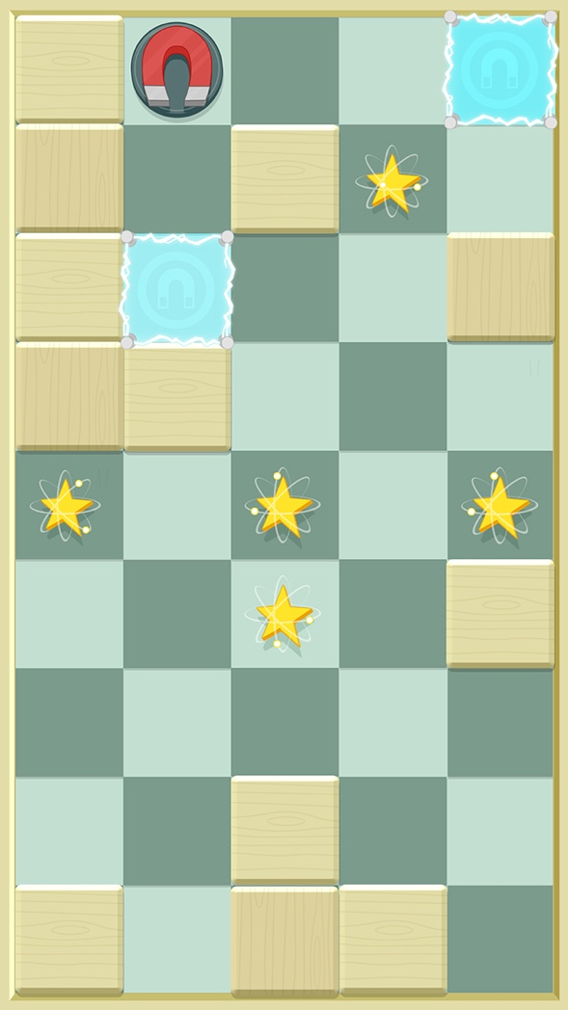

The object of the game is to collect all of the stars by sliding the metal disc over them.

The trick is that the disc can only be moved by attracting it with a magnetic force.

To move the disc in a straight line, the player touches any magnetizable (blue) square in the field to magnetize it. The metal disc will immediately slide toward the square. Once the disc touches the square, it will de-magnetize.

By moving the disc around the field in this manner, the player can collect stars by directing the disc over the square holding the star. The player receives IQ points based on the number of stars collected, and a bonus for the amount of time left in the meter.

Each Magnet-neato assignment can be replayed 3 times if desired.

The highest score attained is kept.

Play is scaled in the following ways:

1. Increased complexity of the field pathways and star positions, making it harder or easier to collect stars quickly.
2. Addition of a blue block element that is repelled if a nearby blue square is magnetized.
3. Addition of a red square that is attracted if a nearby blue square is magnetized.
4. Create a square that contains a depression that will capture the disc if it runs over it.
5. Create blocks that will break after being hit by the disc.

Einstein Interaction

In Magnet-neato, Einstein provides the player with spoken How to Play instructions.

In addition, Einstein offers encouragement and reactions to *key* game successes, like collecting stars.

### Brain Game Option #3: Massamatics

In each round of Massamatics, the player is presented with an unlikely balancing scale (an enormous planet lifting robot called A.T.L.A.S.) meant to weigh very large objects, along with a selection of several planets of varying size and density.

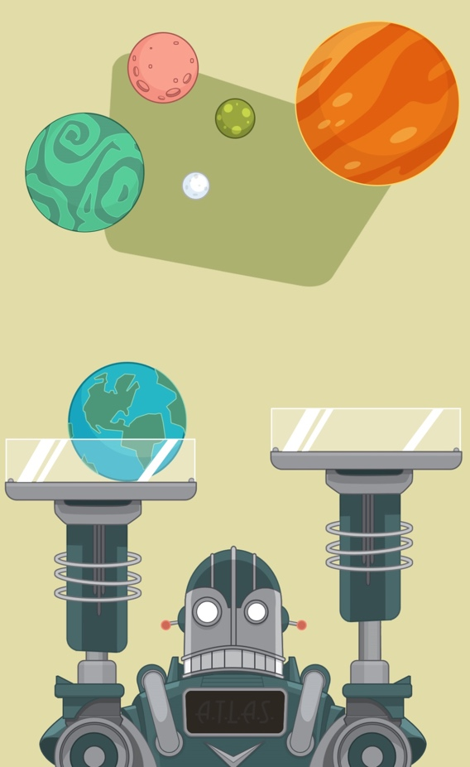

The object of the game is to balance the scale by adding planets (ie. the proper amount of mass) to both sides of the planetary scale.

The player earns IQ reward based on how much time is left in the game timer once the scale is balanced using ALL of the planets.

Play is scaled in the following ways:

1. Create super heavy planets. *Overbalancing the scale can cause it to break.*
2. Certain mixtures of size and mass are more difficult to account for quickly. Eg. a small, super dense planet.
3. Add satellites/moons to planets as an unknown mass factor.

Einstein Interaction

In Magnet-neato, Einstein provides the player with hints when each planet is touched. Listening to the hints will provide vital clues.

In addition, Einstein offers encouragement and reactions to *key* game successes.

### Brain Game Option #4: Threes

In Threes, the player is presented an addition or subtraction ‘equation’ that consists of two known elements and a single unknown element, with each element being expressed as a simple graphic - like a sun, flame, ice cube, flower, etc.

The player’s job is to identify the relationship being expressed by the equation, and ‘solve’ it by dragging the most appropriate element below the equation into the unknown element slot. Most equations express relationships that are rooted in some scientific interaction (water + acorn = tree) or (water + sun = vapor) but other are simply amusing (car – gas can = walking person.)



If the player drags the wrong icon into the variable slot, it disappears in a puff of smoke and the timer immediately loses two seconds of time as a penalty.

The player earns IQ points based on how many equations are solved before time run out, with a bonus earned for every block of three equations solved.

### Brain Game Option #5: Did you NO?

Did you NO? is a quiz game in which the player is presented a ‘fact’ from a number of different scientific categories, and then must determine if it is, in fact, true. The game is a good example of a completely dialog driven activity.

The player earns points based on how quickly each question is answered correctly, and can attempt to answer up to 16 questions before time runs out.

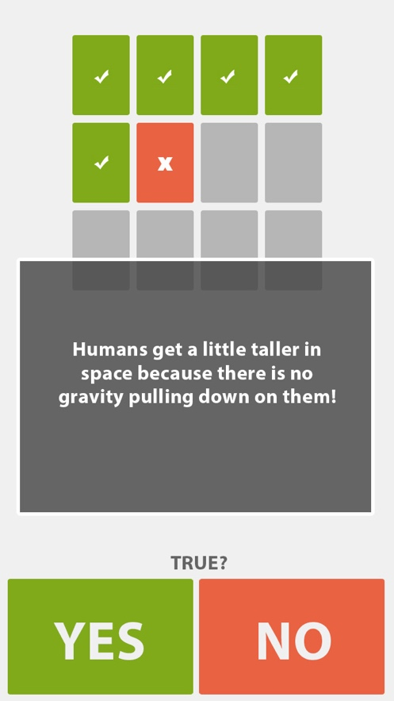

This game can be played verbally, with Einstein asking the questions and reacting to each verbal YES/NO response appropriately.

The scientific ‘facts’ presented in this game should be drawn from some of the facts Einstein conveys to the user at different times during their conversations.

|  |
| --- |
| Daily Kickstart  If a science fact is conveyed during a Daily Kickstart, then Einstein should assign a Did You NO? challenge using that fact. |

## Pi Chart – Scheduling Daily Activities

The Pi Chart is a 12-hour, pie-chart style interface that allows the user to schedule certain activities and reminders. Events in the Pi Chart are ‘downloaded’ into Einstein and will automatically trigger at the appropriate time.

Using the Pi-Chart interface, accessible from the Stein-O-Matic’s main menu, the user can schedule Einstein events on any day of the year. Events can be one time, or recurring.

Scheduled activities fall into one of a two categories: Reminders or Einstein Activities.

Reminders are standard events or reminders that the user might add to any calendar (eg. school, Mon-Fri, @8am-3pm or Piano Lesson, Tues @6:30.) Einstein Activities are Einstein specific - like the Wakeup Call feature. Einstein Activities trigger a specific Einstein function at a specific time, set by the user.

*Any slices in the Pi-Chart that do not have a scheduled activity are filled with a Free Time slice.*

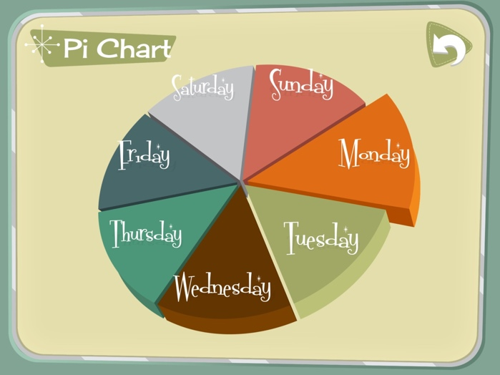

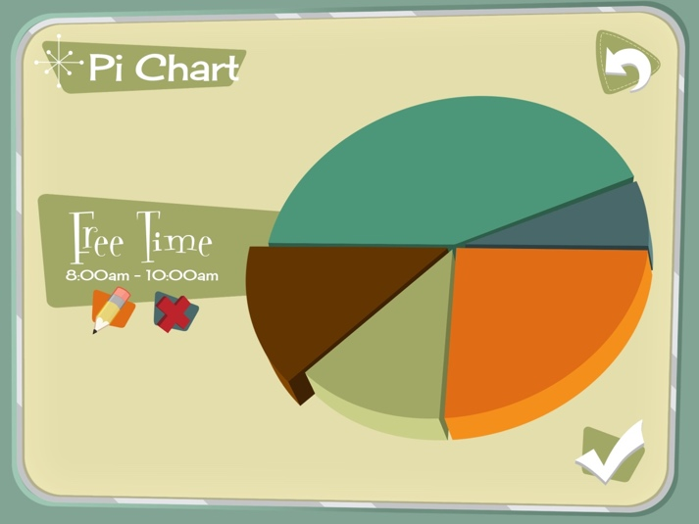

|  |
| --- |
| Daily Kickstart  The user always has the option to set a wakeup call. This is the **Stein-O-Matic** Kickstart.  The **Einstein** Daily Kickstart is a permanent, hidden scheduled activity. However, it is time independent. That is, regardless of the actual time, the Daily Kickstart will take place immediately upon Einstein’s first wakeup each day, assuming a Pi-chart event is not already scheduled. If so, Einstein will wait until the scheduled event is over. |

## Digital Lab Experiments – Combining Imagination and Science

In the Expermiments section of the Stein-O-matic 3000, the user can engage in more in-depth games, with verbal aid and encouragement provided by Einstein. Brain Games challenge the user’s hand-eye coordination and brain agility while teaching basic scientific principles.

*Because of the depth of these games, Einstein will launch with one Experiment. New Experiments can be added post launch.*

### Gravity

In gravity, the user imagines himself traveling home in a spaceship from an interstellar voyage, and having to reach his home planet with only a small amount of fuel left for his rocket engine and energy left in his battery cell. The player must reach Earth, on the other side of the screen, with the aid of the gravity of the surrounding planets. As a way of teaching the relationship between mass and gravity, the player can choose to resize any planet on the screen, or move its position before the level starts. Once the player fires the rocket engine, inertia and gravity take over. If the player has positioned the planetary bodies correctly, his initial rocket boost plus gravity should get him home safely.

The Journey

Each time the player fires his rocket engine, the ship will be at the mercy of the initial thrust vector and the planet’s gravity ‘wells.’ During this phase, the screen zooms in on the ship, following its path around the solar system. While moving, the ship will show the path it’s taken via a curvy dotted line. If the player does NOT reached Earth, the screen zooms back out and we can see clearly the path the ship as taken (due to the dotted line) and make any corrections necessary to the solar system and try again.

Once the rocket engine is fired, the ship is essentially hurtling through space without a pilot. During this journey, the player can use the ship’s very limited battery supply to power his shields and protect it from space debris, heat from stars or the occasional attack from roving alien saucers.

Scientific Principles

The player learns about basic inertia, mass, volume and gravity.

The player learns that the mass of a planet is a factor of its size (volume) and density – and that a more massive object has a stronger gravitational force.

*Note: The planets used during Gravity are the same ones encountered in the Massamatics Brain Game. This familiarity should help the player more quickly setup his solar system for a safe return trip.*

Reward

Successfully navigating home will reward the player with IQ points based on the distance traveled (the longer the better), with a bonus earned for any remaining battery power.

*Note: The Experiments section of the mobile App is designed to be expanded with additional In-App content packs post launch.*

## Research Files – Learning from the Master

In the research section of the Stein-O-Matic, the user can access an expanding library of motion graphic videos on a number of topics. Initially, these topics will be limited to Einstein’s own scientific accomplishments, with other topics available post launch*.*

For each of these topics, a short motion graphic presentation will play out on the Stein-O-Matic as Einstein provides the narration.

The videos will be accessed by locating and selecting them from a list in the Stein-O-Matic, OR by navigating Einstein’s conversational menu tree.

*Dialog navigation is still being designed, but accessing a video via dialog may look like this:*

*“Einstein, can you [TELL] me about [RELATIVITY]?”*

*The keyword [TELL] immediately loads the TELL keyword group in which the keyword [RELATIVITY] launches the relativity video sequence.*

Einstein will launch with (a maximum) of 5 video segments.

* The general Theory of Relativity
* The special Theory of Relativity
* Time
* Gravity
* Photoelectric effect

*In addition to videos on Einstein’s popular areas of research, other knowledge topics will become available post launch. These will be offered as in-App purchases.*

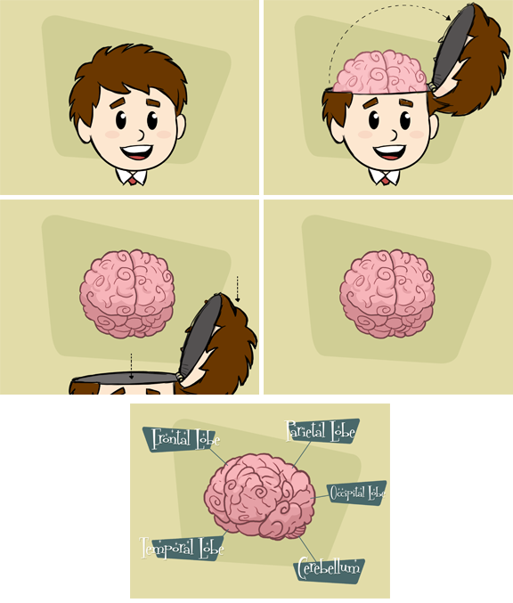

# DIALOG/FLOW 1 – Connecting Einstein

The following flow chart and dialog sheet are first pass examples of how Einstein might lead the player verbally through the process of getting connected to the internet and the mobile App. This section also serves as an example of how keywords may be employed.

* **White blocks** are ID references to Einstein’s verbal response in the dialog sheet.
* **Colored blocks** indicate the doll’s state change
* **Connecting line text** are keywords

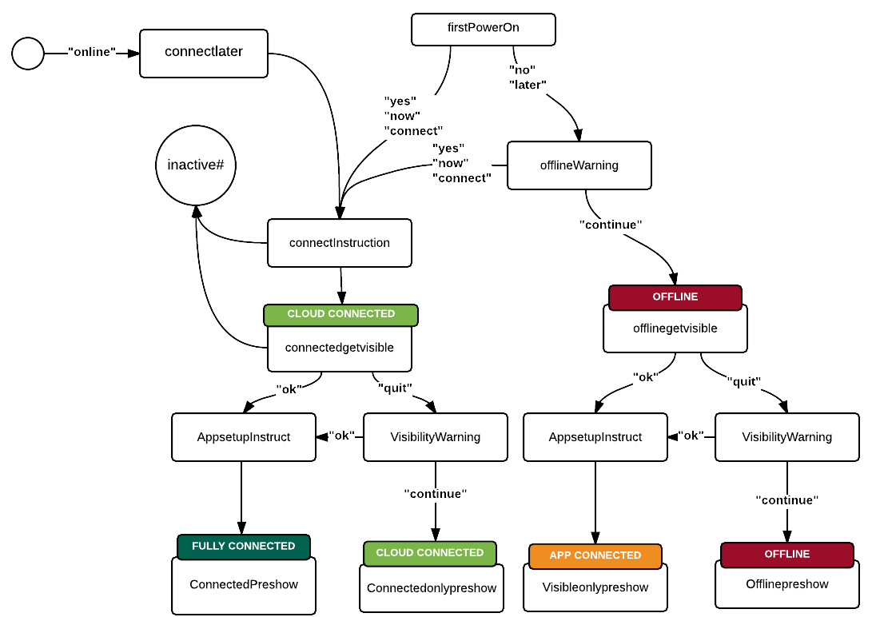

|  |  |  |  |  |
| --- | --- | --- | --- | --- |
| **ID** | **Description** | **Dialogue** | **Expression** | **FX & Notes** |
| firstPowerOn – block 1 |  | Powering up personal companion module. GENIUS mode. Downloading personality dataform 3141879 – Einstein, Albert. Download complete. |  | Sound FX plays. A voice speaks, but it is not the voice of Einstein.  Robot’s eyes remain closed until Player says the wake up phrase. |
| firstPowerOn – block 2 |  | Congratulations. Your Personal Genius is downloaded and ready for activation. To activate, say the words, “Hey Einstein” |  | Reward FX plays.  (would be cool if the player can reprogram the phrase - “What’s crackin, Einstein?” etc.) |
| firstPowerOn – block 2 noresponse |  | To activate your Personal Genius, say the words, “Hey Einstein” |  | Repeats every 10 seconds until activation. If there is no activation after 40 seconds, something should happen. |
| firstPowerOn – block 3 |  | Ooh-hoo-hoo, hello there! So nice to see a friendly face after being in a state of psycho-kinectistasis for so long! Ahhh, it’s wonderful to finally wake up and smell the atoms, but I don’t have to tell you that, am I right? (chuckles) So, let’s get things started, shall we? I think I could be way more helpful to you if I were connected to the Internet (wording?). Do you want to do that now? Yes or no? |  | Player says “Hey Einstein”  Reward FX plays.  Robot servo FX plays.  Einstein wakes as if from a slumber. |
| firstPowerOn – block 3 noresponse |  | What do you say, shall we connect to the Internet? Yes or no? |  |  |
| connectInstruction – block 1 | Set up instructions | Wonderful! Now do exactly as I say or we may disrupt the flow of time and space and bring the universe as we know it to a crashing end! (chuckles) Just kidding! But seriously, pay attention. |  | Keyword: yes  Reward FX plays.  Dramatic music builds up to and subsides after “crashing end” |
| connectInstruction – block 2 |  | ? |  | Actual instructions |
| offlineWarning |  | Okay, no problem. But just so you know, I won’t have access to everything I need to help you discover the secrets of the universe. So if you change your mind at any time, just say “Einstein, online!” |  | Keyword: no |
| connectedgetvisible | Intro app | Now that’s done, I’ve one other thing to show you. I’ve been working on something that will help us organize our searches, our games, our work, and our experiments! I call it the Stein-O-matic. Would you like to check it out now? Yes or no? |  | Working App name |
| Connectedgetvisible norepsonse |  | Would you like to check out the Stein-O-matic? Yes or no? |  |  |
| offlinegetvisible |  | Now that’s done, I’ve one other thing to show you. I’ve been working on an app that will help us organize our searches, our games, our work, and our experiments! I call it the Stein-O-matic. Would you like to check it out now? Yes or no? |  |  |
| Offlinegetvisible noresponse |  | Would you like to check out the Stein-O-matic? Yes or no? |  |  |
| AppsetupInstruct – block 1 |  | Splendid! You know, I didn’t want to say it, but I thought to myself “this will be a true test of genius” And you passed! Okay then, let’s get started. |  | Keyword: yes  Reward FX plays. |
| AppsetupInstruct – block 2 |  | ? |  | Actual instructions |
| visibilitywarning |  | No problem. But FYI, my current theory is that we will have a lot more fun if we use the Stein-O-matic! So if you decide you want to use it, say “Einstein, xxx”! |  | Keyword: no |
| connectedpreshow |  | I think now would be a good time for introductions. I am Albert Einstein, your Personal Genius! Now I’m sure it hasn’t escaped your notice that I’m actually a miniature robot that you recently pulled from a cardboard box, but I would hope you wouldn’t hold that against me. (chuckles) I may be an automaton, but that doesn’t mean I don’t have feelings. So let’s not bring that up again, agreed? Splendid! So enough about what’s so great about me. Let’s find out what’s so great about you, shall we? |  |  |
| Connectedpreshow noresponse |  | Hello? Oh, I see. If I say “Shall we”, you say “we shall”. Okay? Let’s try that again. Let’s find out what’s so great about you, shall we? |  |  |
| connectedonlypreshow |  | Same. |  |  |
| Connectedpreshow noresponse |  | Same. |  |  |
| visibleonlypreshow |  | Same. |  |  |
| Visibleonlypreshow noresponse |  | Same. |  |  |
| offlinepreshow |  | Same. |  |  |
| Offlinepreshow noresponse |  | Same. |  |  |
| Inactive# | If at any point I lose you, just say “I’m confused”  IDK1,2,3 (Einstein is lost) – then repeat instruction | If at any point I lose you or something is confusing, just say “Einstein, you lost me.” |  |  |
| Idontknow 1 |  | Oh no! You caught me daydreaming. Please, ask me again. |  |  |
| Idontknow 2 |  | Sorry, I was lost in thought. Repeat, please? |  |  |
| Idontknow 3 |  | Whoops, my mind was wandering again. What were you saying? |  |  |
| Profileintro – block 1 | Leads you make profile (personal) – explains how your answers will affect your avatar. (this can be broken into blocks) | GREAT! Let’s start by building your avatar. Back in my day, scientists were known only for their accomplishments. But today, people want face time! So they want a face, let’s give them a face! Shall weeee? |  | Keyword: weshall |
| Profileintro – block 2 |  | Good! You remembered! Now, I’m going to ask you a series of very personal questions and I want you to answer honestly even if it means embarrassing yourself in front of the whole world! (chuckles) Just kidding. The questions will be fluffy but meaningful. And every answer you give will affect the look of your avatar. Let’s begin. |  | Keyword: weshall |
| Profileintro – block 3 |  | I’ll wait for you to boot up the Stein-O-matic. |  | Actual questions |
| Profileiconhelp | Player is told where to find profile | Perfect! Now, touch here to access your profile. |  |  |
| profileloaded | Player looks at profile/avatar for first time | Everything I know about you is right here. Your deepest secrets on display 24 hours a day. Like Facebook. But for GENIUSES! |  |  |
| Perfect! | Name confirmation | Look at that. You know your own name! And now, so do I. |  |  |
| profilewrap | Enough of that – what’s next | Okay, that’s enough already with the introductions. I know you, you know me, we like each other very much, blah blah blah. Let’s get to the good stuff, shall we? |  |  |
| Profilewrap noresponse |  | Remember, if I say “Shall we”, you say “we shall”. Okay? Let’s try that again. Let’s get to the good stuff, shall we? |  |  |